# **Deliverable 4**

# **Activity Tracker**

Swapnil Srivastava, Alex Thropp, and Jonas Schulz

**Object responsibilities and collaborations**

* **The system acts as the controller**
* **The System is responsible for knowing date, time, step count, calories burned, and all other user created instances**
* **The user is responsible for creating instances of age, weight, step goal, and calorie goal**
* **The user is responsible for changing the display**
* **Our System is designed with low cohesion in mind, most classes are independent with little interaction, except basic variable and object handling.**

**Class Diagram**

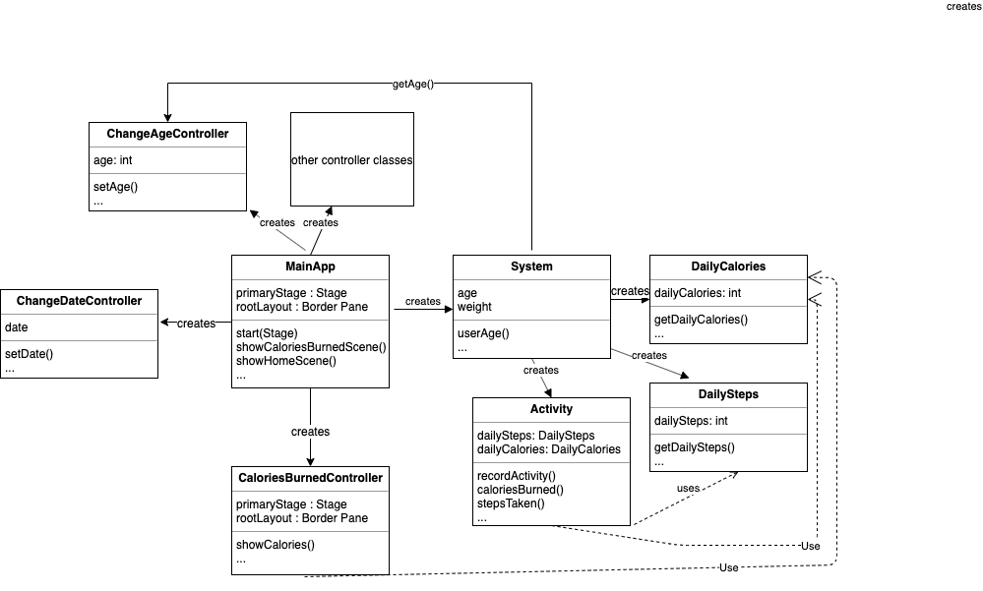

**Sequence Diagrams**

* Recording activity
  + :system is the controller
  + :activity acts as the creator
  + High cohesion

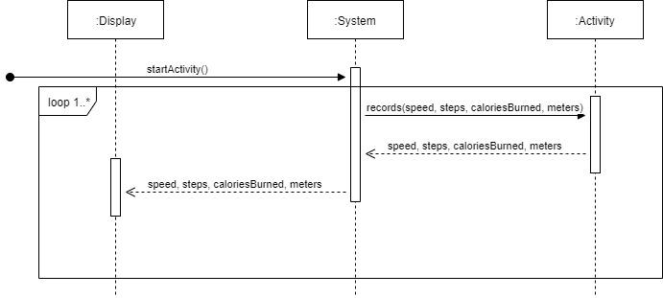

* See daily steps
  + :system is the controller
  + :dailySteps acts as the information expert
  + High cohesion

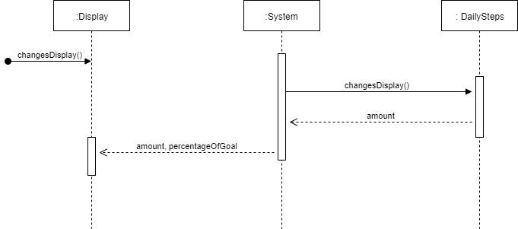

* See Calories Burned
  + :system is the controller
  + :dailyCaloriesBurned acts as the information expert
  + high cohesion

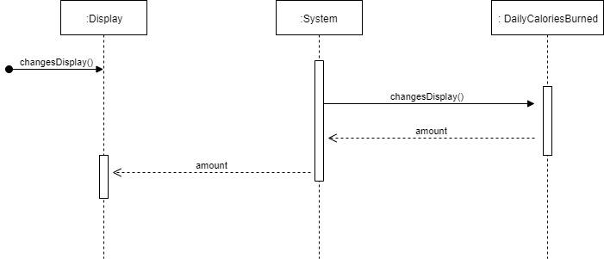

* Start sleep
  + :system is the controller
  + :activity acts as the creator
  + high cohesion

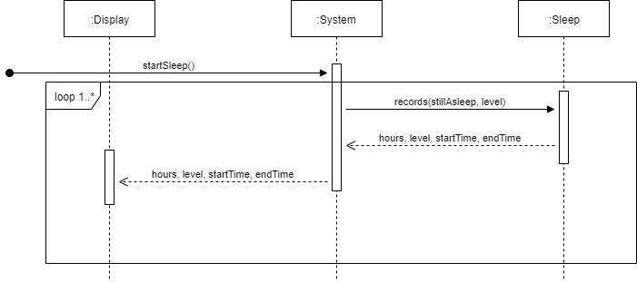

* Change age
  + :display acts as controller
  + :System act as the creator
  + high cohesion
  + Low coupling

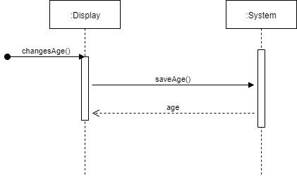

* Change weight
  + :display acts as controller
  + :System act as the creator
  + high cohesion
  + Low coupling

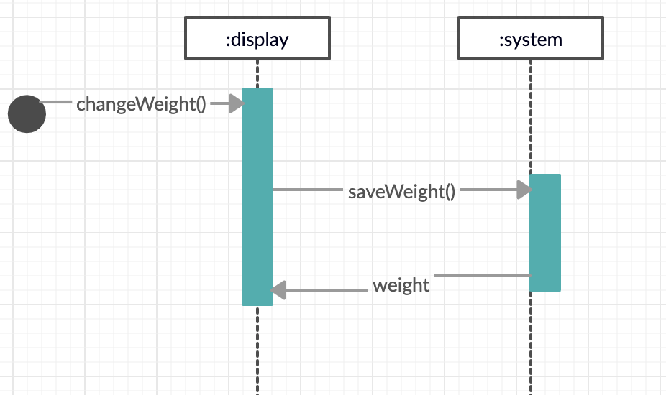

* Change time
  + :display acts as controller
  + :System act as the creator
  + high cohesion
  + Low coupling

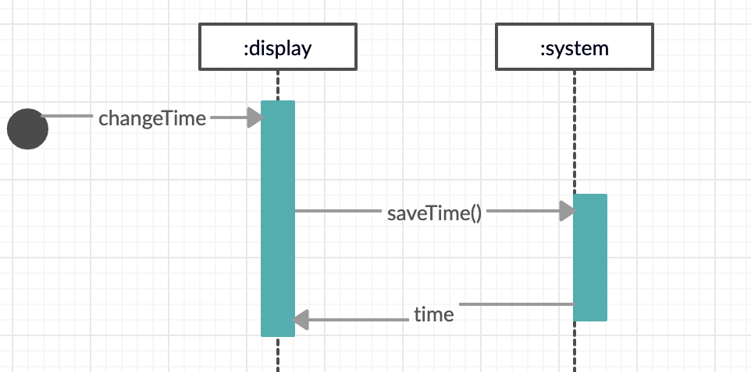

* Change date
  + :display acts as controller
  + :System act as the creator
  + high cohesion
  + Low coupling

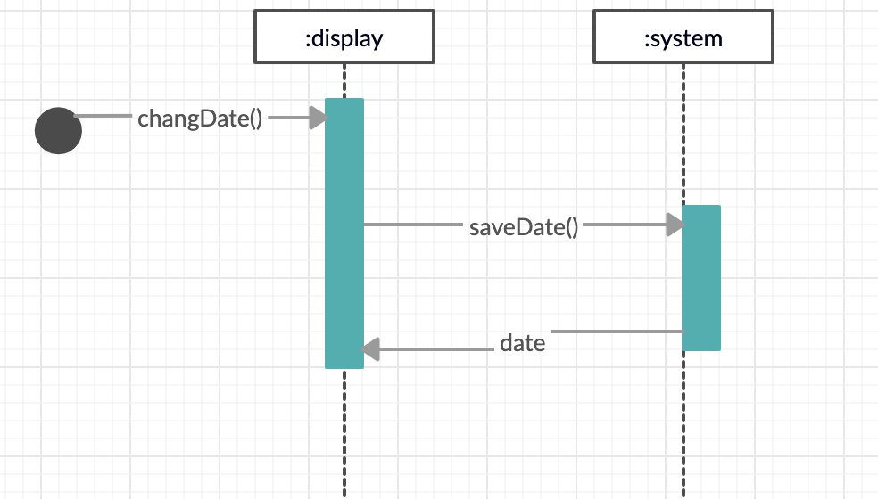

GRASP patterns and responsibilities of objects

|  |  |  |
| --- | --- | --- |
| **Class** | **Responsibility** | **GRASP pattern** |
| MainApp | Starts the program, creates controllers and System, and controls the scene flow | Creator, controller, and pure fabrication |
| Activity | Saves data about activity | Information expert, low coupling |
| DailyCalorie | Saves calorie data | Information expert |
| DailySteps | Saves steps data | Information expert |
| ColoriesBurnedController | Controls the calorie burned scene | Controller |
| System | manages activity and user data | Information expert and pure fabrication |
| ChangeAgeController | Controls change age scene | controller |
| ChangeDateController | Controls change date scene | controller |